TEST PLAN FOR:
<https://parabank.parasoft.com/>

ChangeLog

Version | Change Date | Changed By | Description | Approved By
1 | 24/09/2024 | Amaresh Muddebihal | Overal planning of the strategy about the online banking website. | N/A

Table of Content

1 Introduction 2
1.1 Scope 2
1.2 Quality Objective 2
1.3 Roles and Responsibilities 2
2 Test Methodology 3
2.1 Overview 3
2.2 Test Levels 3
2.3 Bug Triage 3
2.4 Suspension Criteria and Resumption Requirements 3
2.5 Test Completeness 4
3 Test Deliverables 4
4 Resource & Environment Needs 4
4.1 Testing Tools 4
4.2 Test Environment 4
5 Terms/Acronyms 5

Introduction
For the specific online banking website testing, continuous checking, security testing, proper functionality testing is cruitial and the overall strategy has been created to ensure the proper user experience as well as confidentiality.

Scope
The objective is to identify and report any defects, inconsistencies, or usability issues that the users encounter while exploring the website.
The details of the testing objectives are as follows:
1. Functional Testing:
- Register a new user account.
- Log in to the user account.
- Verify that account details, balance, and transaction history are displayed accurately.
- Test the fund transfer and bill payment functionality.
- Ensure that all hyperlinks and buttons function as expected.
2. Usability Testing:
- Evaluate the overall user interface for intuitiveness and clarity.
- Check if the navigation is easy and logical.
- Validate that error messages are informative and user-friendly.
- Verify the website's responsiveness on different devices (desktop, tablet, and mobile).
3. Cross-Browser Testing:
- Test the website on at least two different web browsers (e.g., Chrome, Firefox, or Edge).
- Ensure that the functionality remains consistent across different browsers.

Quality Objective

The overal objective of the project is to-
- Ensure the website Under Test conforms to functional and non-functional requirements
- Ensure the Application Under Test meets the quality specifications defined by the client
- Bugs/issues are identified and fixed before go live
- Defects should not be skipped before launching the final output

Roles and Responsibilities
Following members are responsible for their respective roles and responsibilities:
- QA Analyst
- Test Manager
- Configuration Manager
- Developers
- Installation Team

Test Methodology

Overview

Since it is an online banking website and continuous improvement, feedback, changes according to the users requirements is necessary, following an agile approach seems suitable for it.

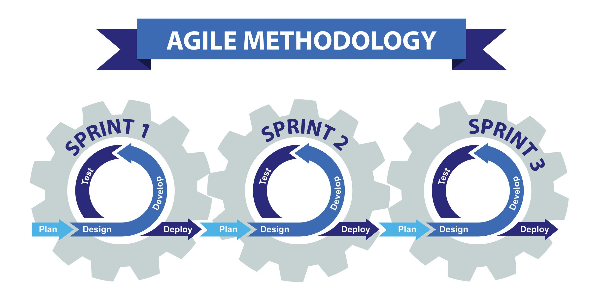
By this process, the planing development and testing can be improved continuously to ensure the proper user quality if service.

Test Levels

- Functional Testing:
  - Register a new user account.
  - Log in to the user account.
  - Verify that account details, balance, and transaction history are displayed accurately.
  - Test the fund transfer and bill payment functionality.
  - Ensure that all hyperlinks and buttons function as expected.

- Usability Testing:
- Evaluate the overall user interface for intuitiveness and clarity.
- Check if the navigation is easy and logical.
- Validate that error messages are informative and user-friendly.
- Verify the website's responsiveness on different devices (desktop, tablet, and mobile).

- Cross-Browser Testing:
- Test the website on at least two different web browsers (e.g., Chrome, Firefox, or Edge).
- Ensure that the functionality remains consistent across different browsers.

Bug Triage
The goal of the triage is to:
- To define the type of resolution for each bug
- To prioritize bugs and determine a schedule for all “To Be Fixed Bugs’.

Test Completeness
Here you define the criterias that will deem your testing complete.
For instance, a few criteria to check Test Completeness would be
- 100% test coverage
- All Manual & Automated Test cases executed
- All open bugs are fixed or will be fixed in next release

Test Deliverables
Here mention all the Test Artifacts that will be delivered during different phases of the testing lifecycle.
Here are the sample deliverables
- Test Plan
- Test Cases
- Requirement Traceability Matrix
- Bug Reports
- Test Strategy
- Test Metrics
- Customer Sign Off

Resource & Environment Needs

Testing Tools
Testing tools required are:
- Bug Tracking Tool- JIra
- Automation Tools – Not used

Test Environment
It mentions the minimum hardware requirements that will be used to test the Application.
Following software’s are required in addition to client-specific software.

- Windows 8 and above
- Office 2013 and above
- MS Exchange, etc.

